  Property:  Unit 701, 7th Floor, 100 Queen’s Road Central  Area:  2,251 sq.ft. Gross (approx.)  Monthly Rental:  HK$70 p.s.f.  Monthly Air-Conditioning & Management Fee:  HK$7.25 p.s.f.  Availability: Immediate  Features:  - Conveniently located with covered walkway  connecting to Hong Kong Station  - Car Parking Facilities  - Ceiling Height : 2.8m (approx.)  - Fully fitted with 3 manager offices & 1 server room  - MOVE-IN CONDITIONS  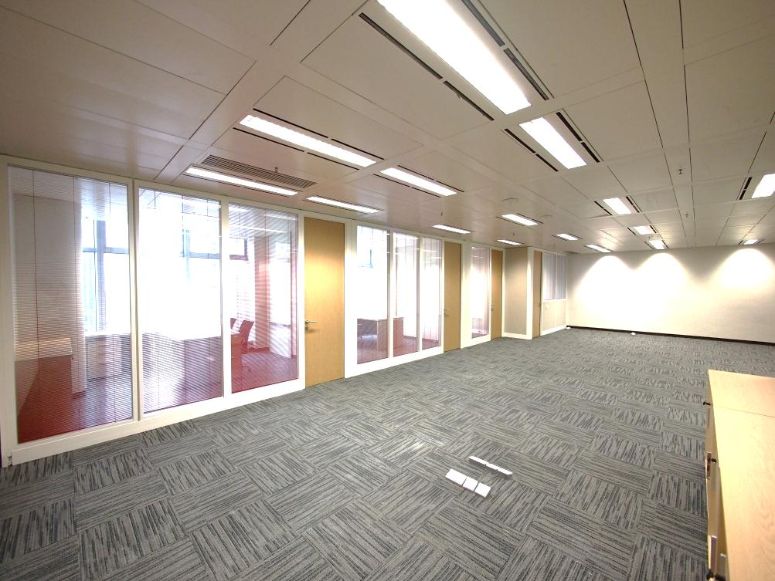  Visit:www.100QRC.com | 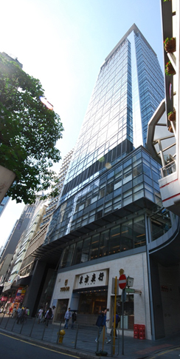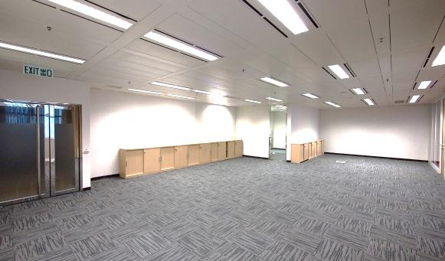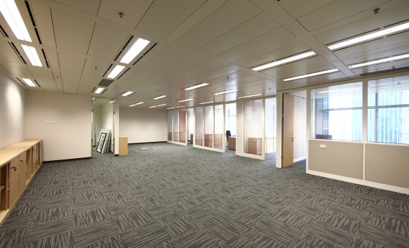  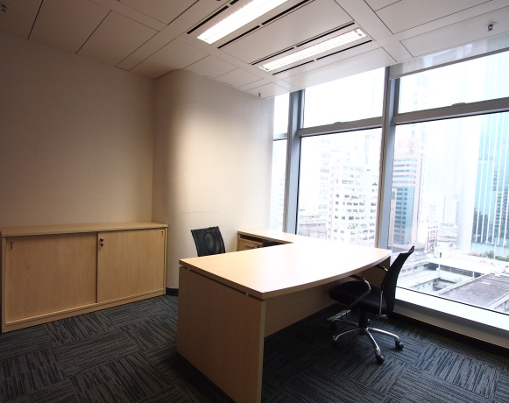
7/F FLOOR Layout Plan
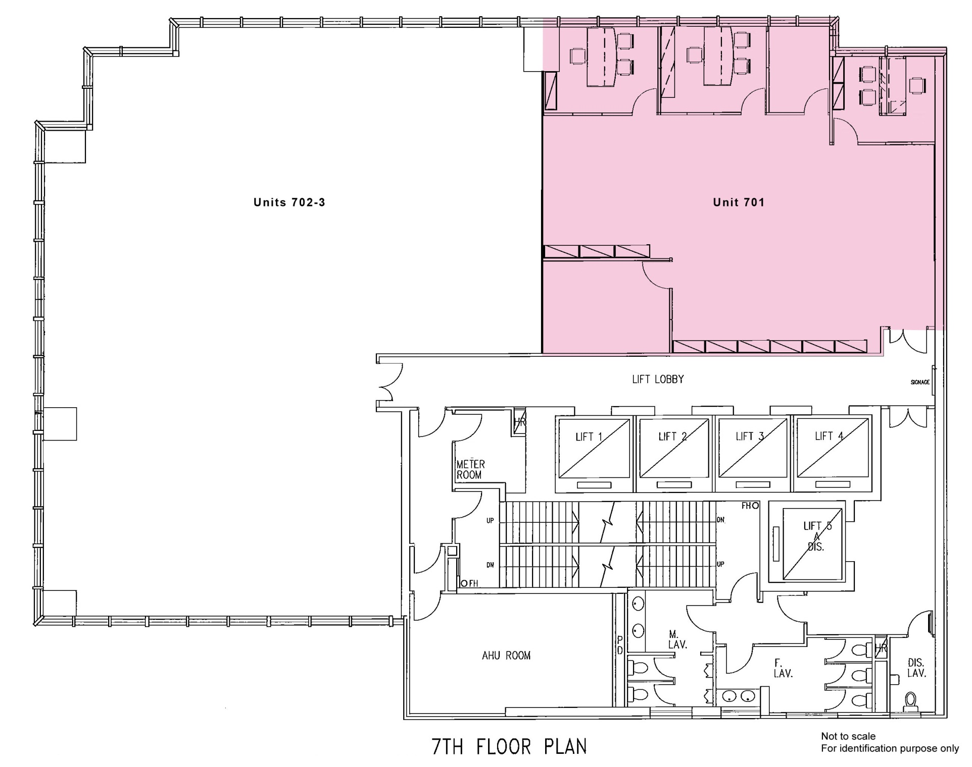Not to scale
For identification purpose only

